CMSC 204

Huffman Lab

1. Create a Huffman Tree and generate the codes for each character of the following input:

create a huffman tree

For consistency:

1. If same frequency – put in priority queue alphabetically; put space before other characters of the same frequency
2. Add subtrees to end of group with same priority
3. Lower number has higher priority (goes to front)

21

13

7

8

4

6

4

3

2

2

4 ‘e’

3 ‘a’

3 ‘ ’

2 ‘t’

2 ‘r’ ‘r’

2 ‘f’

1 ‘u’

1 ‘n’

1’ m’

1 ‘h’

1 ‘c’

e – 111, a – 101, ‘ ’ – 100, t – 001, r – 000, f – 1101, u – 1100, n – 0111, m – 0110, h – 0101, c – 0100

Now encode “create a huffman tree”

c r e a t e ‘ ’ a ‘ ’ h u f f m a n ‘ ’ t r e e

0100 000 111 101 001 111 100 101 100 0101 1100 1101 1101 0110 101 0111 100 001 000 111 111

**0100000111101001111100101100010111001101110101101010111100001000111111**

1. Based on the following Huffman tree and binary sequence, what is the text

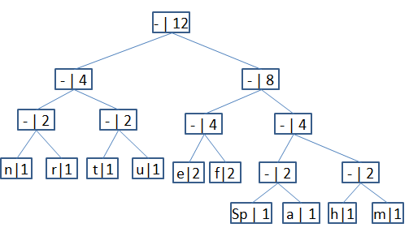

1110011101101111111010001100010001100100

1110 011 101 101 1111 1101 000 1100 010 001 100 100

h u f f m a n ‘ ’ t r e e

**huffman tree**